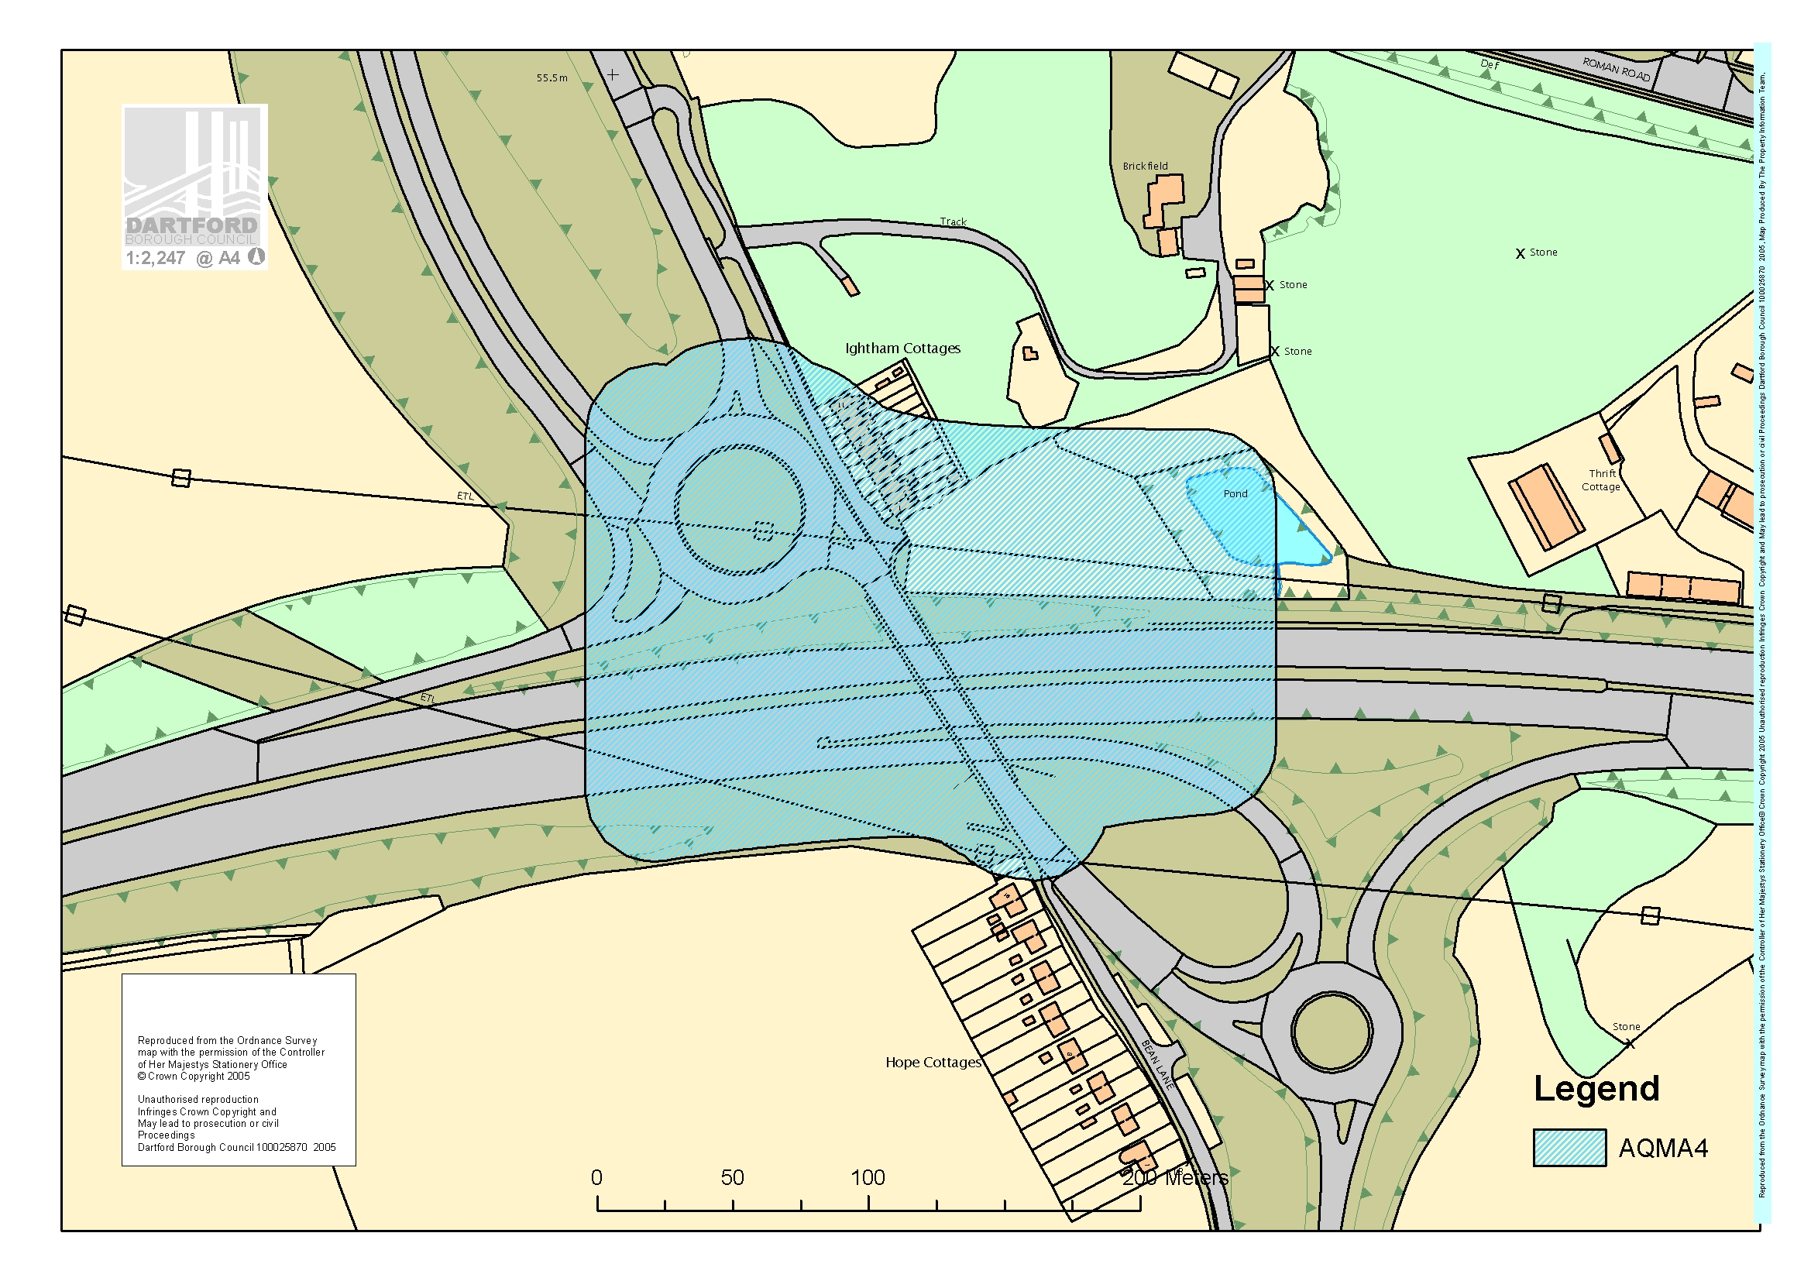
AQMA 4 Bean Interchange

